**Neural network model for popping**

**Single neuron dynamics**

$C\frac{dV_{k}}{dt}=-g_{L}\left(V_{k}-V_{L}\right)-w_{k}+g_{L}∆_{T}\exp\left(\frac{V_{k}-V^{T}}{∆_{T}}\right)+I_{in}^{k}+\overline{w_{Vol}}Vol$ (1)

$τ_{w}\frac{dw_{k}}{dt}=a\left(V_{k}-V_{L}\right)-w_{k}$ (2)

$${if V}_{k}≥V_{sp}→V_{k}=V_{reset} and w_{k}=w_{k}+b$$

**Synaptic current**

$τ_{s}\frac{dI_{in}^{k}}{dt}=-I_{in}^{k}+\sum_{i=1}^{N}{\sum_{j=1}^{sp}{δ_{i}(t-t_{j})}}$ (3)

**Actuator dynamics (muscle)**

$τ_{A}\frac{dr_{A}}{dt}={-r}_{A}+\overline{w_{A}}\sum_{i=1}^{A}{\sum_{j=1}^{sp}{δ_{i}(t-t_{j})}}$ (4)

**Volume dynamics (plant)**

$τ_{V}\frac{dVol}{dt}=Vol-V_{o}-Φ_{V}(r_{A})$ (5)

$Φ_{V}\left(r_{A}\right)=0$ if $r_{A}$ <=Thr, else $Φ_{V}\left(r_{A}\right)=Step$

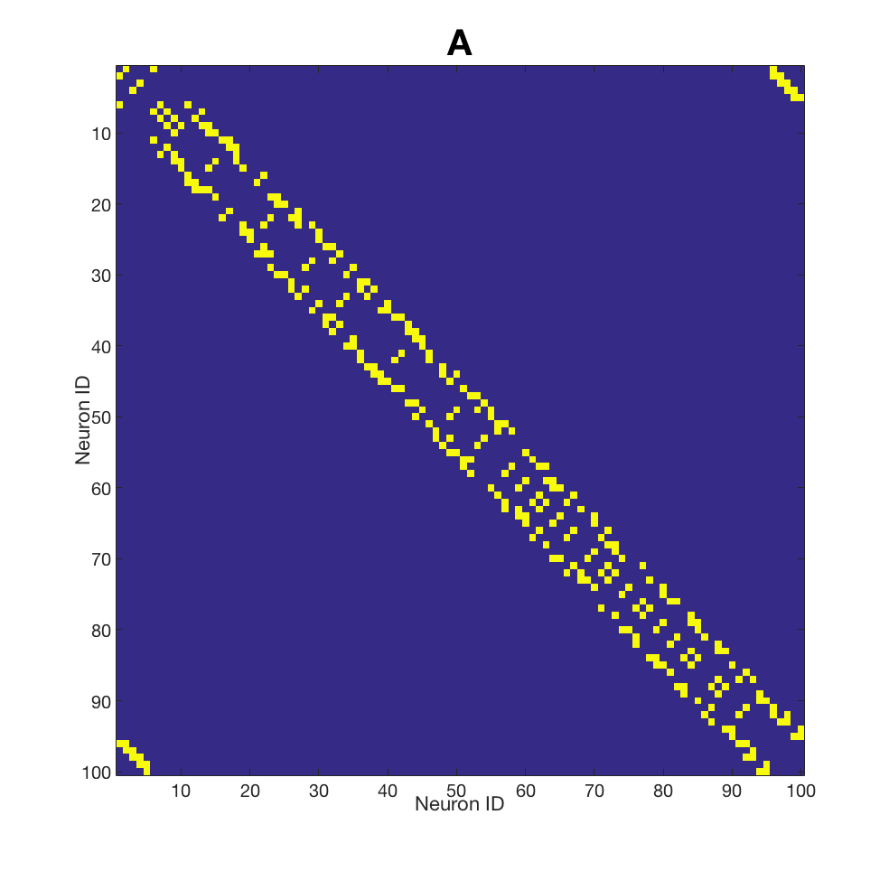

**Connectivity**

N – number of neurons

S – number of sensors

A – number of actuators

sp – spikes in the spike train

$\overline{w_{A}}$– vector of actuators weights

$\overline{w_{Vol}}$– vector of sensory weights

**Indexes**

k – index over neurons

i – index over synapses

j – index over spikes

Summation over synaptic connections is organised by sparse connectivity matrix **A**